DATA ENCAPSULATION

This is the process via which data manipulates during flow through the OSI layers.

Some additional bits are added to the original data at various layers. These bits are called data header and this process is called data encapsulation in networking. This process is done on both sides i.e snder and receiving nodes/ data changes at every layer of OSI layer.

Each layer uses PDUs for transmit and receive information on OSI.

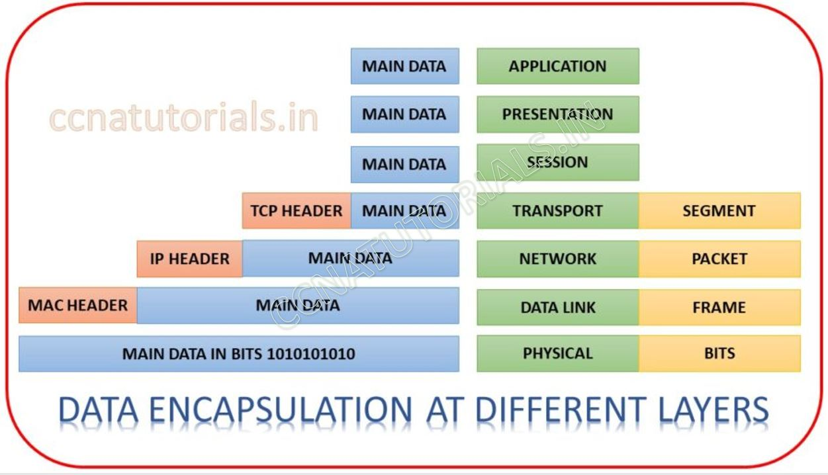

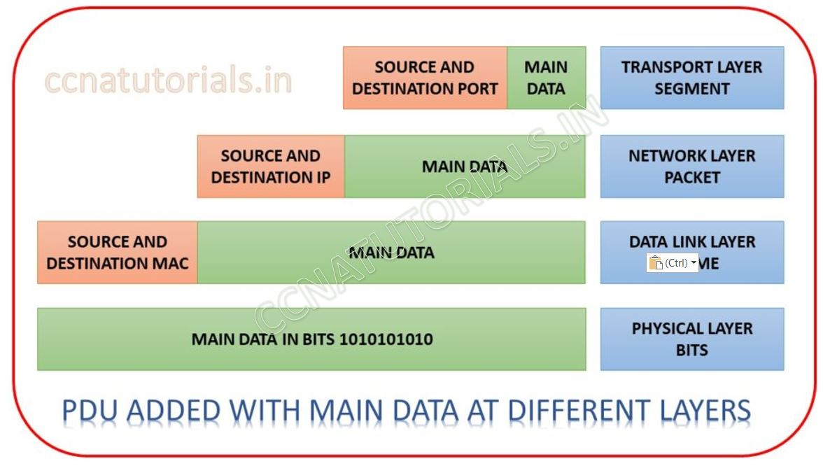

**Data Encapsulation at transport layer**

At transport layer during transmitting data, the segment breaks in to [packets](https://ccnatutorials.in/network-fundamentals-ccna-200-301/switching-concepts-in-networking/). A header added to each [packet](https://ccnatutorials.in/network-fundamentals-ccna-200-301/switching-concepts-in-networking/). This header consists the port address of source and destination. Ports are used for various services on the same [IP address](https://ccnatutorials.in/network-fundamentals-ccna-200-301/ip-address-system-in-computer-networking/). For example, [http](https://ccnatutorials.in/application-layer-of-tcp-ip/http-hypertext-transfer-protocol/)works on port 80 and [https](https://ccnatutorials.in/application-layer-of-tcp-ip/https-hypertext-transfer-protocol-secure/)works on port 443. The PDU attached with packet defines the service for the data. During reception transport layer check the port address at each packet and make segments. Then the segment transformed into the real data.

Data Encapsulation at network layer

At [network layer](https://ccnatutorials.in/tcp-ip-model/tcp-ip-suite-model-basic-concepts/) during transmitting data, Packets received from transport layer. Each packet contains a header PDU in which the [port address](https://ccnatutorials.in/network-address-translation/nat-network-address-translation/) is bind. Network layer breaks each packet into frame and add a PDU header. This PDU header consist the IP address of source and destination. A stream of frames transferred to data link layer.  During receiving the data network layer read the [IP address](https://ccnatutorials.in/network-fundamentals-ccna-200-301/private-ip-address-in-computer-networking/) in each PDU and forward the packets to the destination [IP address.](https://ccnatutorials.in/tcp-ip-model/ip-address-system-in-tcp-ip-model/) This work is done by a router in a [network](https://ccnatutorials.in/internetworking/networking-basics-in-ccna/). That’s why a Numbers of computer work in a [LAN](https://ccnatutorials.in/internetworking/local-area-network/)send and received their relevant data from a [single router gateway](https://ccnatutorials.in/ip-routing/ip-routing-in-router/).  At the time of transmitting data this process is called data encapsulation and during receiving data it is called data de-encapsulation.

**Data Encapsulation at Data Link Layer**

Data link layer received packets from [network layer](https://ccnatutorials.in/network-fundamentals-ccna-200-301/layer-2-and-layer-3-switch-in-networking/). These packets contain two headers which are added by above two layers. These headers contain the information of [port address and IP address](https://ccnatutorials.in/network-address-translation/nat-network-address-translation/). Data link layer is not related to these PDU in any way. Data link layer attached its own PDU during transmission and de-attached the PDU during reception of data. When transmitting data packets breaks up into frame. A header added to each frame. Data link layer work on [MAC address](https://ccnatutorials.in/layer-2-switching/layer-2-switching-basic-concepts/) for example layer 2 switch. PDU containing [MAC address](https://ccnatutorials.in/network-fundamentals-ccna-200-301/switching-concepts-in-networking/) added to each frame at data link layer. A stream of PDU added frames transferred to physical layer. During receiving data, the stream of bits received from physical layer and frame constructed. MAC address deducted from the header and frames transferred to network layer.

**Data Encapsulation at Physical Layer**

A stream of frames received from data link layer. Physical layer breaks the frame in to digital signal or bits. Converted bits are transmitted over the physical media. During receive data, the physical layer constructs frame from the received bits and handed over to data link layer.